Design Thinking Lab 1 Report

Topic: Electricity Outage Information Is Not Communicated Clearly

Name: Alfred Antony

Roll no: 24BTCE225

Step 1: Observation

Observation Log
Context observed:
Unplanned and planned electricity outages in residential and semi-urban areas; information accessed via electricity board offices, helpline numbers, SMS alerts, and social media.
User Behaviour
- Users repeatedly check power switches and meters to confirm outage.
- Many users call customer care numbers multiple times.
- Some users depend on neighbors or local electricians for information.
- Businesses switch to generators without knowing outage duration.
Delays, Confusion, and Frustration
- No prior notification for sudden outages.
- Helpline numbers are busy or provide generic responses.
- Conflicting information from different sources.
- Users are unsure about restoration time.
Environmental / System Constraints
- Limited mobile network during outages.
- No centralized, real-time communication platform.
- Manual updates by field staff cause delays.
Documentation
- Notes from local observations.
- Screenshots of unanswered helpline calls.
- Photos of notice boards with outdated outage information.

Step 2: User Identification

Stakeholder List
User Group | Role | Expectations
Residential Consumers | Daily electricity users | Timely and accurate outage updates
Electricity Board Staff | Maintenance and fault repair | Reduced complaint calls and clear communication
Commercial Users (shops, hospitals) | Depend on continuous power | Advance notice and restoration timelines
Local Administrators | Information coordination | Fewer public complaints and transparency
Output: Stakeholder Identification

Step 3: Interviews / Surveys

Interview Questionnaire (Open-ended)
- How do you usually find out about a power outage?
- What information do you expect during an outage?
- Have you ever received incorrect or delayed outage information?
- How does poor communication affect your daily routine?
- Which communication method do you trust the most?
- What improvements would you suggest?
- How often do outages occur in your area?

Interview Summary (30 Users)

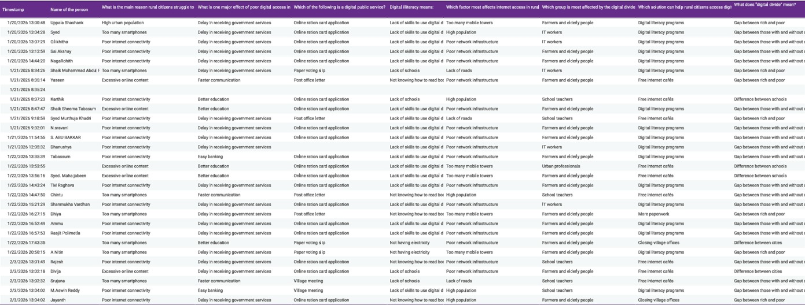
Common User Statements
- “We never know how long the power will be gone.”
- “Customer care never answers during outages.”
- “If we knew the timing, we could plan better.”
- “Messages come after power is restored.”
- “Hospitals and shops suffer huge losses.”

Step 4: Pain-Point Analysis

Pain-Point Table
Pain Point | Category
No advance notification | Functional
Unclear restoration time | Functional
Anxiety and stress | Emotional
Loss of work and income | Emotional
No single reliable information source | Systemic
Poor coordination between departments | Systemic
Most Critical Pain Point:
Lack of clear and timely outage communication

Step 5: Root Cause Identification

5-Why Analysis
Problem: Users do not receive clear outage information.
- Why? → Updates are delayed or missing.
- Why? → Information depends on manual reporting.
- Why? → Field staff lack real-time update tools.
- Why? → No centralized digital communication system.
- Why? → Low investment in customer communication infrastructure.
Root Cause:
Absence of an integrated, real-time outage communication system

Step 6: Wicked Problem Understanding

Wicked Problem Explanation
- Difficult to define clearly:
Communication failure varies by region, outage type, and user dependency.
- Multiple stakeholders:
Consumers, electricity boards, administrators, emergency services.
- Conflicting needs:
Cost efficiency vs. real-time transparency.
- No single solution:
Requires technology, policy changes, training, and coordination.
Problem Classification: Wicked Problem

Step 7: Reflection

1. What assumptions were incorrect?
Initially, it was assumed that electricity providers already inform users properly and that people can easily find outage details online or through SMS.
However, user feedback showed that notifications are delayed, unclear, or sometimes not received at all, and many users do not know the restoration time or reason for the outage.

2. How did user perspectives change your understanding?
User perspectives revealed that the problem is not only technical but also communication-related.
People feel frustrated, unprepared, and anxious during power cuts because they lack clear, timely, and reliable information.
This shifted the understanding from a simple outage issue to a user experience and information transparency problem.

3. Why is jumping to solutions risky?
Jumping directly to solutions (like creating an app or sending SMS alerts) without understanding users may result in tools that people cannot access, trust, or use effectively.
Proper research is needed to ensure the solution provides real-time, simple, and widely reachable communication that truly solves the users’ problem.

4. What skills did you develop through this lab?
This lab helped develop empathy for users, problem observation, user research, critical thinking, and solution planning skills.
It also improved the ability to analyze real-world communication gaps and design user-centered digital solutions.

